* **User Registration and Authentication Process:**

* **User registration Window**

**User Inputs:**

* Full Name
* Email Address
* Password
* Confirm Password

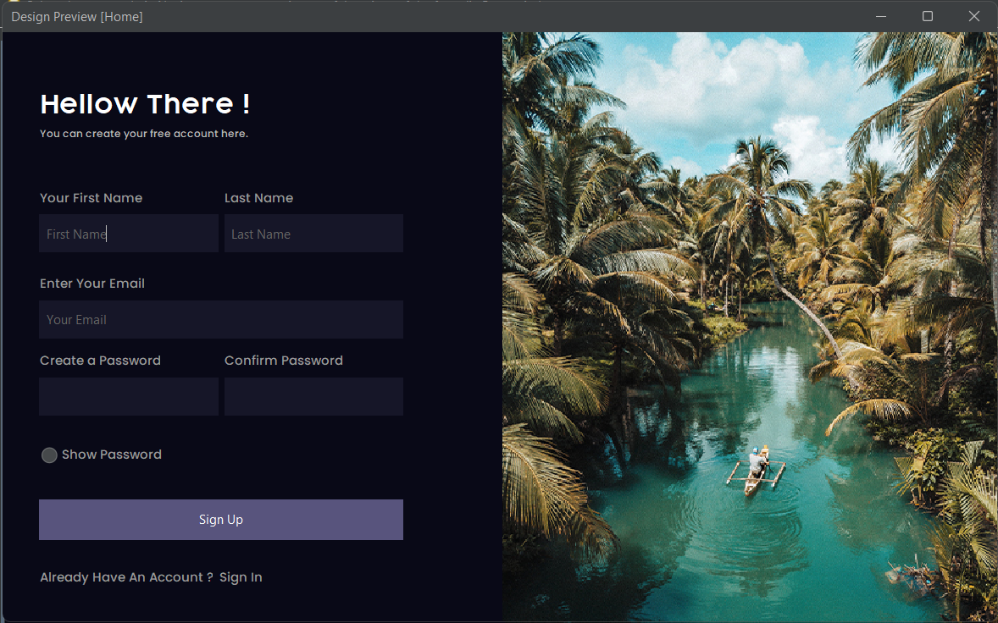

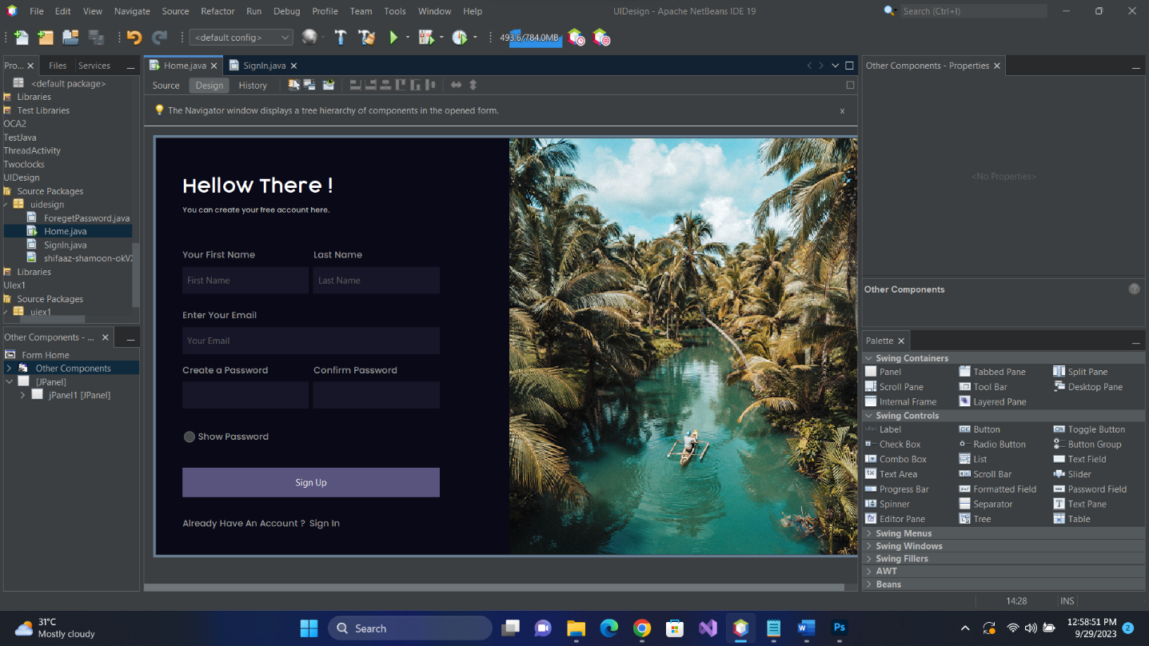

# • Sign In Window

**User Inputs:**

* Email Address
* Password

